
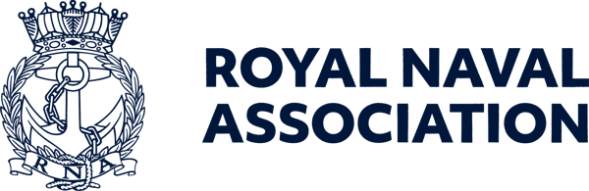

Semaphore Short Friday 11 September 2026

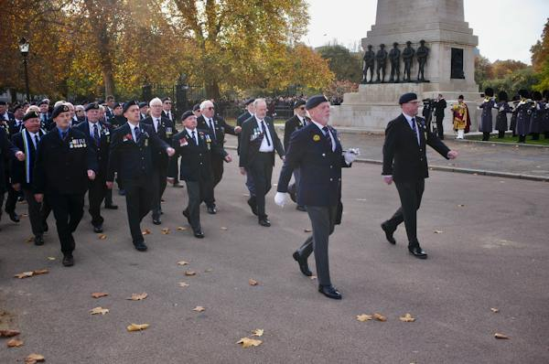

Last call for Remembrance Sunday

This is your last chance to claim your place in the RNA contingent which will march along Whitehall in London on Remembrance Sunday.
We have a couple of dozen spaces left for the event, on 8 November, but the deadline for registering details with the Royal British Legion is fast approaching.
Any shipmates interested in joining in the November ceremonies should register their interest by emailing Jon Boreham at ams@rnassoc.org without delay.
Please note – those registering with the RNA will be expected to march with the 140-strong RNA contingent.
In order to march you must possess at least one of the following:
• Veterans Recognition (ID) Card
• Veterans UK Status Card
• Certificate of Service – this must include date of discharge
• Certificate of Discharge
• Veterans Railcard
• For Merchant Mariners – a copy of the personal details page of your Discharge Book, along with the vessel names on which you served and the operation names and date.
Please check the RBL website for eligibility details: https://www.britishlegion.org.uk/.../remembrance-sunday
Following the parade at the Cenotaph, the RNA will host a sandwich lunch reception for 50 members (on a first-come, first-served basis) at the Civil Service Club at 13-15 Great Scotland Yard, London SW1A 2HJ.

Eyes on the prize

There are now just three weeks until the Uckers World Championships, but there is still time to join in the fun.
Hosted by the RNA at the Royal Maritime Hotel in Portsmouth on Saturday 3 October, registration on the day is open from 0900 to 1000, and players of any standard, from novice to expert, are welcome to try their hand.
The first dice are cast at 0930, and spectators are most welcome at the event, which promises plenty of thrills and excitement.
There are solo and pairs competitions, and we are keen to see ships and establishments represented, as well as branches or areas.
To help us plan, please register your interest by emailing Milly at ceo-ea@rnassoc.org with your name, contact details and whether you're entering solo or with a teammate



Army v Navy tickets now available

RNA members can now apply for tickets for the Army v Navy rugby double header at Twickenham on Saturday 1 May next year.
The Association has an allocation of 1,350 tickets exclusively reserved for RNA members. For 2027, tickets will be available through a dedicated
members-only booking link, which will be sent directly to members who request tickets.
Please note: To protect our allocation, this booking link must remain confidential and must not be shared with anyone else.
The RNA experience provides:
- A dedicated RNA seating
- Exclusive access to our private clubhouse bar.
Enjoy the day alongside fellow RNA members, friends and family.
The rugby kicks off at 1400 for the senior men’s clash, with the women’s match following at 1645.
If you are bringing a crowd, purchasers of ten or more tickets will receive a ten per cent discount on their booking.
Contact us to request your members-only booking link and secure your place before our allocation is exhausted.
Email Milly on ceo-ea@rnassoc.org

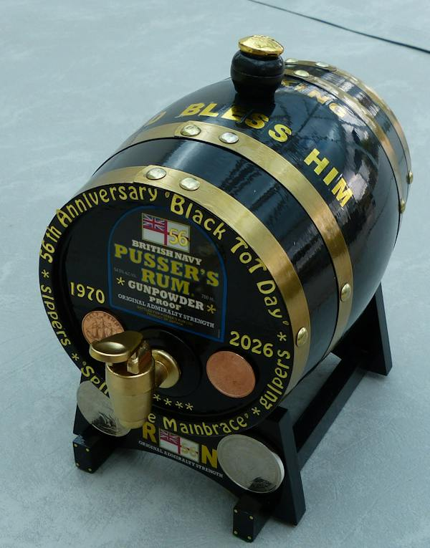

Rum barrel is under the hammer

Shipmate Wally Blagden has created a unique 2.5 litre anniversary rum barrel that celebrates several historic Naval anniversaries, and the barrel is up for auction, with bidding currently standing at £500.
Money raised will be donated to the RNA Central Charity Fund.
The current highest bidder, who wishes to remain anonymous, has expressed an interest in presenting the barrel to the Association to auction once more at a Trafalgar Night dinner.
The barrel (pictured above) includes several special coins, including a King George VI 1950 halfpenny (representing the RNA’s 75 anniversary last year), a 1970 Galleon halfpenny (for the 56th anniversary of Black Tot Day), and a King Charles III 2026 £5 crown, marking 500 years of the crown coin.
The new barrel was created following a similar initiative marking the 50th anniversary of Black Tot Day.
Bidding will close on 3 October to coincide with the RNA World Uckers Championships.
If you would like to make a bid, you can send it to RNA Central Office at ceo-ea@rnassoc.org and we will pass it on to Wally.

Are you pension aware?

Next week, as part of the MOD's Pension Awareness Week 2026, the White Ensign Association (WEA) is hosting a free live webinar for serving personnel, reservists and veterans, covering AFPS 75, 05 and 15, plus Early Departure Payments.
WEA Armed Forces Pension experts Dave Scholey and Marty Small, who are Royal Navy and Royal Marines veterans, will explain the schemes, what they mean for their members and answer questions throughout the live session.
The webinar will be held on Wednesday 16 September, 1300–1430, online via MS Teams.
Your Armed Forces pension is a valuable asset. Know your scheme. Know your entitlements. Know your choices. Be pension aware!
You must register to attend, using this link: https://events.teams.microsoft.com/event/317d7a71-f9e3-48e1-a572-119a56acfd70@9e902c46-439c-4b5d-b4ae-572ded6ed2b9



Run through Lapland – or Rome

The RNA is pleased to support SSAFA, the Armed Forces charity – they give us much support throughout our branch network and, indeed, many of our members are also SSAFA caseworkers.
If you want a challenge, and to support SSAFA, they are asking for people from the Naval Family to step out and join them – and here are a couple of things we thought you might enjoy...

SSAFA Warrior Challenge – Lapland, January 2027
Imagine running across frozen lakes, dense pine forests and sweeping white landscapes, all beneath vast Arctic skies.
Choose from 25k or 50k. This event will also be attended by Big Phil Campion!
For more details see
https://www.ssafa.org.uk/support-us/events/ultra/ssafa-warrior-challenge-lapland

Or run through history at the Rome Marathon
Imagine crossing the finish line in one of the world's most iconic cities, surrounded by thousands of runners from across the globe, with over 2,000 years of history lining every step of your journey.
The Rome Marathon, on 14 March 2027, is more than a race. It's an unforgettable experience.
For more details see
https://www.ssafa.org.uk/support-us/events/run/rome-marathon-2027

Central Office maintenence work

Central Office staff will be moving out of Lanyard House next Friday (18 September) in preparation for maintenance work which will be carried out on the building’s roof and electrical wiring.
This means we will not be able to attend to our normal business and routines that day.
From the following Monday (21 September) a limited number of Central Office staff will be operating from a smaller location in the Naval Base, while others will work from home.
The maintenance programme is scheduled to last for around 11 weeks, though any additional issues that are discovered along the way may affect that estimate.
Whilst we will make every effort to maintain business as usual, you may very well experience some delays, including responses to questions you send our way. Please accept our apologies for any disruption, and thank you all for your patience and understanding.

  Shop for the Association
  You could turn your everyday shopping into support for the RNA without spending an extra penny.
  Whether you're buying gifts, booking a holiday, or ordering your weekly essentials online, you could be raising free donations for the Royal Naval Association through easyfundraising.
  Simply sign up, select the RNA as your chosen charity, and participating retailers will donate on your behalf at no additional cost to you.
  It’s free to join, there are thousands
  

of retailers involved, and every donation helps support members, veterans, and their families
Start fundraising the easy way – use this link: https://tinyurl.com/54b34d42 or use the QR code (above right). You just need to click ‘Support this Cause’, create a free account, and start shopping with participating retailers via the website, app or browser extension.
Once you’re registered, donations will be automatically generated whenever you make eligible purchases.



Do you fancy a trip to the Maldives?

There is still time for you to win a fabulous prize of an exotic holiday in the RaiseHero 50/50 Raffle, of which Royal Navy & Royal Marines Charity is one of the beneficiaries.
Enter from just £5 for your chance to win incredible prizes while helping to support those who serve in the Royal Navy, Royal Marines and Royal Fleet Auxiliary.
The main draw takes place on 30 September, with the top prize being a luxury Maldives holiday for two, with white-sand beaches, crystal-clear waters and £10,000 cash to spend. Or you could take home a £20,000 cash alternative.
And if you spend £25 or more and you’ll be entered into a bonus draw to win £1,000 cash.
There are also weekly bonus prizes, so the earlier you enter, the more bonus draws you'll be eligible for:
- Ninja coffee machine – 15 September
- Nintendo Switch – 22 September
Every entry supports the Royal Navy & Royal Marines Charity, with 50 per cent of tickets purchased helping those who serve, have served, and their families.
For full details of the raffle and rules see https://rnrmc.the5050raffle.com

 |  |  |  |  |  |  |  |  |  |  | 

